

News Release
January 26, 2017
GS Yuasa Lithium Power

Orbital ATK Selects GS Yuasa and EaglePicher Technologies to Power Joint Polar Satellite System (JPSS-2)

Roswell, GA – GS Yuasa Lithium Power (GYLP), the US subsidiary of GS Yuasa Corporation (GYC) (Tokyo Stock Exchange: 6674), and EaglePicher Technologies, LLC, jointly announced today that Orbital ATK has selected EaglePicher to design and manufacture a battery with specifications to use lithium-ion cells manufactured by GS Yuasa Technology (GYT) to power the Joint Polar Satellite System (JPSS)-2 spacecraft.

JPSS is a partnership between the National Oceanic and Atmospheric Administration (NOAA) and the National Aeronautics and Space Administration (NASA). In March 2016 the NASA awarded Orbital ATK a contract to build up to three Joint Polar Satellite Systems (JPSS) spacecraft. Satellites in the JPSS polar-orbiting constellation gather global measurements of atmospheric, terrestrial and oceanic conditions. JPSS delivers key information and images used for forecasting severe weather such as hurricanes, tornadoes and blizzards and assessing environmental hazards such as droughts, forest fires, and air quality. The information obtained from satellites in the JPSS constellation will help to increase the timeliness and accuracy of forecasts and reduce the potential for property damage and loss of human life.

GYLP will work with their long-time partner, EaglePicher, to incorporate GYT’s Gen III LSE134 lithium-ion cells into the battery system. GYLP and EaglePicher have partnered for over a decade and have been awarded numerous aerospace programs. The JPSS-2 battery is a 7.9 kWh, 29.6V system that integrates EaglePicher’s successful GEOStar-3 and ICESat-2 lithium ion battery platforms to deliver a proven battery design.

Orbital ATK selected GS Yuasa & EaglePicher based on EaglePicher’s expertise in battery design and manufacturing; GYT’s LSE cell heritage, performance and reliability; and each company’s extensive experience supporting US aerospace customers. “GYLP is pleased to continue our partnership with EaglePicher in support of another Orbital ATK satellite program” said Curtis Aldrich, Director of Business Development. “Selection for this program demonstrates Orbital ATK’s continued confidence in GS Yuasa’s lithium-ion technology to meet NOAA’s requirements for schedule, performance and mission life.”

“The strong partnership between GS Yuasa and EaglePicher has been a proven approach in providing the space industry with world-class battery performance” said Ron Nowlin, Vice President & General Manager of EaglePicher Aerospace. “We are excited to again be chosen by Orbital ATK in support of a space mission that is critical to the betterment of human life”.

GS Yuasa Lithium Power
GS Yuasa is one of the world’s leading battery manufacturers for automotive, telecom, and industrial applications and has produced commercial lead acid batteries for more than one hundred years. GS Yuasa manufactures a variety of specialty battery technologies, among them Lithium-ion, Nickel-Metal Hydride, Thermal batteries and Silver Zinc.
GS Yuasa Lithium Power, Inc. is the United States subsidiary of GS Yuasa focused on large format lithium ion battery system manufacturing for US customers. Primary products are lithium-ion battery systems for aerospace, defense, commercial, and industrial applications.

About EaglePicher Technologies, LLC
EaglePicher Technologies, LLC, a VECTRA company, has been a leading producer of batteries and energetic devices for more than one hundred years, currently serving the defense, aerospace, and medical industries. The company provides unmatched experience and capability in battery electrochemistry. EaglePicher also provides custom battery assemblies, battery management systems, pyrotechnic devices and custom power solutions. EaglePicher Technologies is headquartered in St. Louis, Mo., and is ISO9001:2008 and AS9100C certified. For more information, visit www.eaglepicher.com
# # #

For additional information, please contact:
GS Yuasa Lithium Power, Inc. EaglePicher Technologies, LLC
1150 Northmeadow PKWY Suite 118 1215 West C Street
Roswell, GA 30076 USA Joplin, MO 64801 USA
888.GSYUASA (888.479.8272) 417.623.8000
678.892.7501 (fax) 417.680.7412 (fax)
media@gsyuasa-lp.com inquiry.technologies@eaglepicher.com
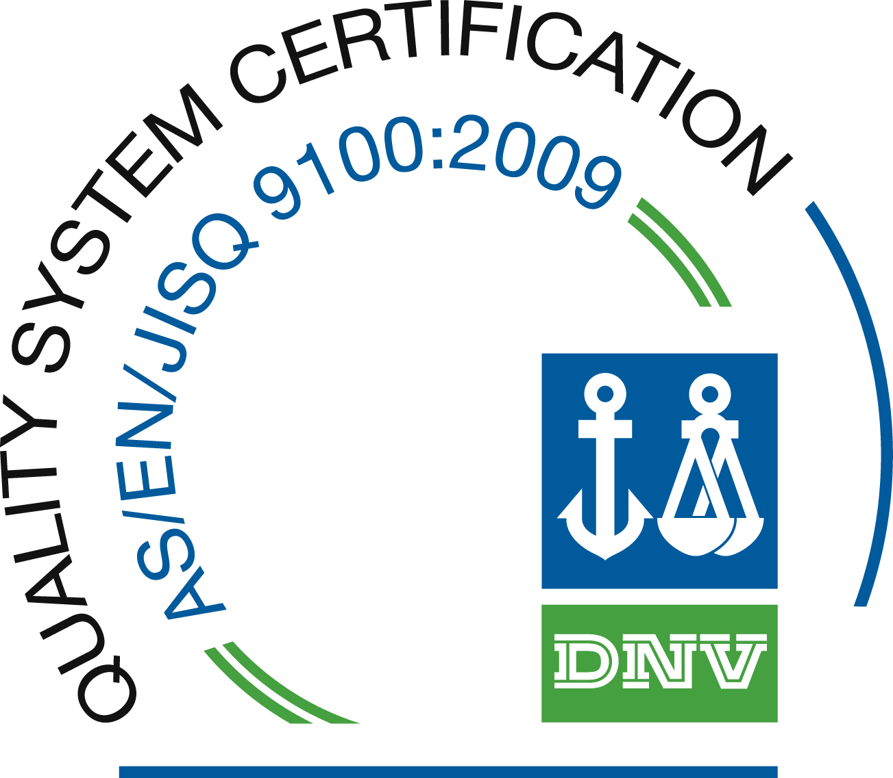
http://www.gsyuasa-lp.com http://www.eaglepicher.com

